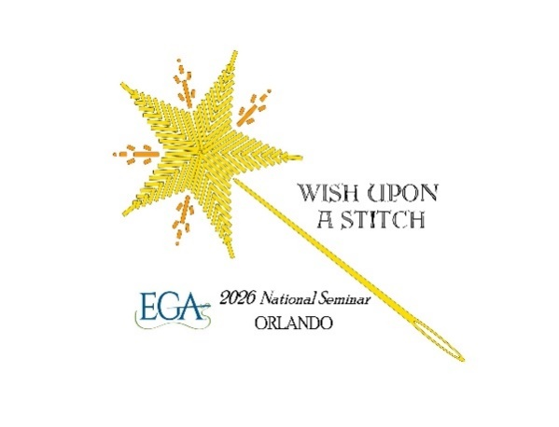

2026 EGA Seminar “Wish Upon a Stitch” – Pop-Up Shops – Vendor Information
October 10-14, 2026
Location
Hyatt Regency Orlando, 9801 International Drive Orlando, FL 32819
Pop-up Shop Schedule
Saturday Oct 10: 11:30 am to 6 pm.
Sunday Oct 11: 9 am to 6 pm
Monday Oct 12: 9 am to 8:30 pm (this is the teacher merchandise event night so people will be out shopping later)
Tuesday, Oct 13: 9 am to 6 pm
Wednesday, Oct 14: 9 am to 1:30 pm

Booth Cost 10X10 booth space
Booth includes up to three 6-foot tables and two folding chairs.
- $150 for the first day.
- $75 for each additional day.
- Vendors may bring their own tables and display racks but please be aware it needs to fit in your assigned space.

Booth Cost 20 X10 booth space- we have a very limited number of these spaces
Booth includes up to six 6-foot tables and two folding chairs.
- $300 for the first day.
- $150 for each additional day.
- Vendors may bring their own tables and display racks but please be aware it needs to fit in your assigned space.

If you book a booth for the entire 5 days- your booth is at no charge on Wednesday, October 14th.

How to Reserve Your Space
Once you decide when you would like to have a booth, contact Deby Talley at 2026eganationalseminar@gmail.com to request a Vendor Contract. Please provide booth size requested, day(s) desired and if you need access to power (and let us know what the power is being used for). Once the contract is finalized and signed, your payment will be due no later than July 15, 2026.

Please note space is limited and all vendor booths will be awarded on a first come-first served basis.

Hotel Information
Vendors who wish to stay at the Hyatt Regency Hotel may take advantage of the Seminar rate by making reservations through this link: https://www.hyatt.com/en-US/group-booking/MCORO/G-EGAS or by calling : (402) 593-5048. The group code is EGA 2026 You must mention that you are part of the EGA 2026 National Seminar to book the seminar rate.

The seminar rate is $189.00, plus 13.625% state and local taxes per night. Rooms may have a king bed or two double beds. This rate is good for the following dates: October 9-October 15, 2026

To confirm a guest room reservation within the EGA seminar room block, the room must be secured with a valid credit card along with a first night’s deposit,

Hotel Address
Hyatt Regency Orlando
9801 international Drive
Orlando, Fl 32819
Phone: 407-284-1234

Parking
The Hyatt Regency Orlando is pleased to offer seminar attendees a discounted on-site self-parking rate. Guests staying at the hotel will receive a 50% discount per day, while non-hotel guests attending the seminar will receive a 25% discount per day. The current self-parking rate is $45.00 per day. Valet parking is also available at $56.00 per vehicle, per day. Please note that all rates are subject to change.

Other Details
- We ask each vendor to supply a door prize with a minimum value of $20. These prizes will be awarded during seminar at “Stitching Time”. The prize can be merchandise or a gift certificate.
- Final payment is due July 15 2026.
- The schedule above indicates when the shopping area will be open. Vendors can choose to be open during the entire time indicated or for shorter hours, if they wish.

Questions?
Please reach out to Deby Talley or Claire Nardone at 2026eganationalseminar@gmail.com

Thank you for your interest!

