**Proposal Submission gUIDELINES**

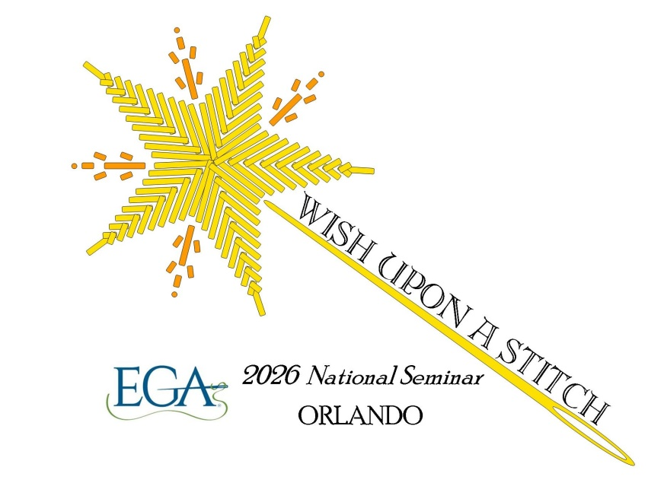

**EGA National Seminar 2026**

**Hosted by Sun Region**

**Hyatt Regency**

**9801 international Drive**

**Orlando, Florida**

**Proposal Submission Guidelines**

**General Information:**

The Embroiderers’ Guild of America National Seminar will be held in Orlando, Florida. The dates are October 9 – 14, 2026and our theme is ***Wish Upon A Stitch***. We invite all teachers to submit proposals. The following information is provided to guide teachers in the preparation and submission of their teaching proposals.

Teachers are expected to arrive in Orlando on Thursday or Friday before the beginning of seminar, depending upon classes selected, unless otherwise advised at the time of selection confirmation. Seminar teaching dates will be Friday, through Wednesday. If selected, the teacher will receive a teaching fee of $450 per class day for 6 hours of class or $225 per class day for 3 hours of class. The seminar will offer four, three, two, one and half day classes in person. In addition, virtual classes will be considered as well. Lectures may also be submitted for consideration as a speaker. Your contract will also include travel, room and per diem.

**Instructions:**

Instructions must be carefully followed. If information submitted is incomplete or incorrectly prepared, the proposal may not be considered. Set pieces should have a design which is either original, an adaptation which has been modified through significant changes, or an encore.

An encore is defined as a project previously taught at any venue. Encore classes will be considered if enrollment history supports consideration. Prior enrollment documentation must be submitted with the completed ICNA Form.

Multiple proposals may be submitted for half day, one day, two day, three day, and /or four day classes so that the faculty selection committee may have a broad selection from which to choose. A limited number of four day proposals will be considered.

Half day classes may be a set project, but they could also be a skill-building technique such as how to lace a slate frame, how to stitch a hardanger lacy edge, how to execute Jean Hilton-type stitches, or how to create realistic silk ribbon flowers on a canvas. These are just some examples. You, as a teacher, know the techniques many stitchers struggle to master. This could be a refresher course, especially if your other projects include these techniques.

Our seminar format will be half and one day classes on the first day of seminar, which will be Friday, October 9. These classes will be limited to no more than a combination to fill five classrooms for one day. Saturday and Sunday will have two-day classes, possibly three-day classes and the first two days of four-day classes. Monday will have one day classes, the last day of some three-day classes and possibly the first day of additional three-day classes. Tuesday and Wednesday will have two-day classes and the final two days of four-day classes. Virtual classes may be held either before seminar or after seminar.

All proposals submitted must state whether the class has been taught before or is available for sale as a kit/class on any social media or online platform. Any selected proposal may not be taught or posted for sale on any social media or online platform between contract execution until 30 days after Seminar 2026 unless permission has been granted by the dean of faculty in consultation with EGA’s director of education. Consideration will also be given to classes which may be taught face-to-face through an online application, such as Zoom.

At the discretion of the seminar committee, projects designed in collaboration with an outside source may be accepted.

Please specify if the proposed project is part of a series or is very similar to other pieces that you have taught or has been previously published. If so, please include photographs of the previous pieces and indicate when and where they were or will be taught.

A teacher shall be expected to teach the class materials on a one-time basis to a pilot group. If selected to teach, a copy of Procedures for a Pilot Group will be sent with the contract.

**Proposal format for sending electronically shall include:**

1. A cover page with a digital image, line drawing or other visual reproduction of the class. This should be the first page sent with each proposal.
2. Proposal Summary. This is the second page.
3. The class description, objectives and other pertinent information about the class on one or two pages.
4. No more than two pages of biographical information and teaching experience.
5. A list of supplies that students must bring with them.
6. Estimation of any pre-work required for the piece.
7. Description of kit, supplies or equipment provided by the instructor.
8. Kit price within 10-15% of final cost.
9. **All proposals must be submitted by email** and received by the Dean of Faculty no later than 5pm, Central Time, on February, 19, 2025.

*Required forms are available from the Dean of Faculty or online at www.egausa.org.

Email notification regarding selection or non-selection will occur on or before **April 15, 2025.**

**Send proposals to:**

Gaye Smith

EGA National Seminar 2026

[Faculty2026@egausa.org](mailto:Faculty2026@egausa.org)

225-931-1381