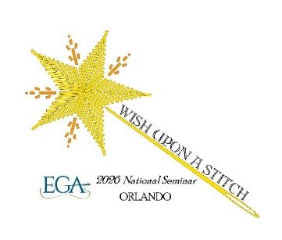
EGA Facilities
Use Policy

A one-time facilities use fee of $430 applies to a nonparticipant or any person registering for two or more days of classes but not staying at the Hyatt Regency Orlando, 9801 International Drive, Orlando Florida, for at least one night, or to anyone staying at the Hyatt Regency Orlando with a room rate other than the EGA-negotiated rate, or persons booking their room using hotel or credit card reward points, as their stay will not be considered part of the seminar room block which contributes toward payment of event and classroom space. If there are exceptions necessary, they need to be approved by the NSC director, or deputy director acting on behalf of the director.

