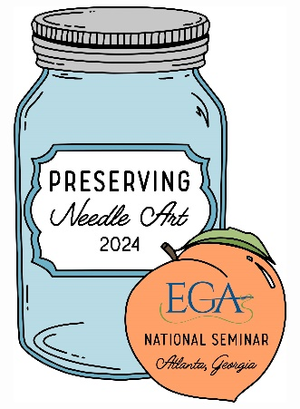
2024 EGA National Seminar

Official Merchandise

Bill To Name: ___________________________________
Ship to Address: _________________________________
City: _________________________________
State: ______ Zip: ____________________
Phone Number: _________________________________
Email: _________________________________________

Item Description Quantity Price per Unit Total
Lunch Box |  | $25.00
Needle Minder |  | $10.00
Beaded Amulet – downloadable .pdf only – no postage fee |  | 10.00
Shipping via USPS 1st class mail– will be added to invoice |  |  | 7.00
TOTAL ORDER

Invoice will be emailed to the address provided above through Paypal. You do not have to have a PayPal account if paying by credit card. Print this form and email it to Lynette Maton at lmaton2@yahoo.com
Payment may be made via PayPal, credit card or check or make check payable to:EGA 2024 National Seminar and mail to:
Lynette Maton
15435 Thorntree Run
Milton, GA 30004

Thank you for supporting EGA’s 2024 National Seminar, Preserving Needle Art in Atlanta! See ya’ll there!

