Zoom Lectures
Catherine Jordan
Chapters will set up the Zoom meeting. Lecture fee: $175.
Some of the programs have pdf handouts. All lectures approximately 1 hour.

Creating Needlework Maps

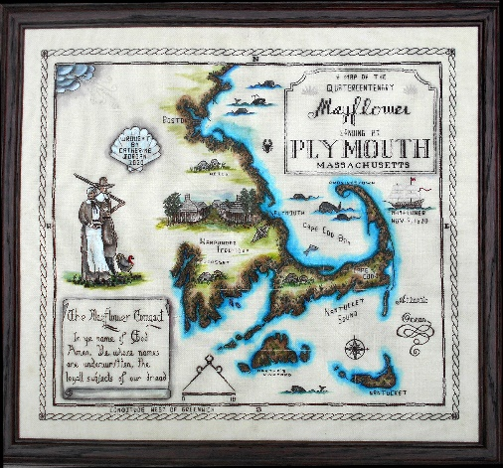
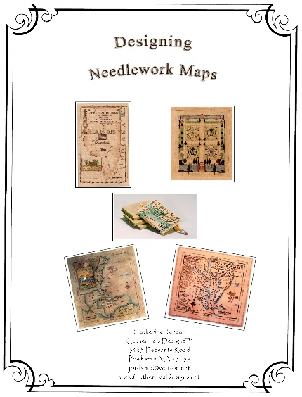

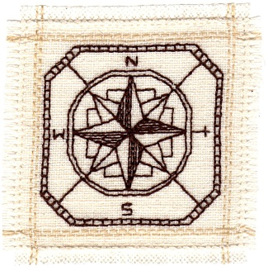
Come and enjoy this “show and share” lecture on creating needlework maps! You will see Catherine’s collection of commemoratively based needlework maps in a PowerPoint program as she talks about the process of where ideas come from, what makes a valuable map, and the intricacies of designing, stitching, and painting needlework maps. Also covered will be the historical basis for many of these maps as styles, motifs, lettering, and coloring effects add to the designs. There will be plenty of time for questions and answers as you learn more about needlework maps.

Accompanying the lecture will be a small black work Compass Rose companion piece emailed in pdf format. Supplies needed: 8" x 8" linen, embroidery floss (your choice of color), and #26 tapestry needle.

A 1-hour Zoom® Power Point® program with 50+ slides exploring the creation and design of needlework maps.
If you have any questions or need additional information, please contact me.

Catherine Jordan
3435 Pleasants Road
Powhatan, VA 23139
804.314.5755
jordancd@verizon.net
Needlework Book Covers

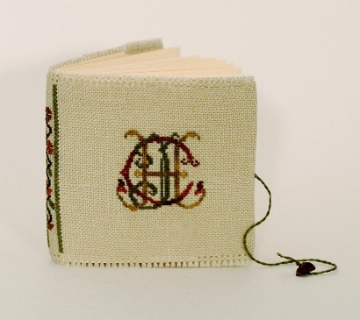

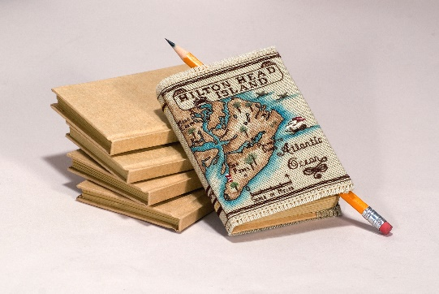

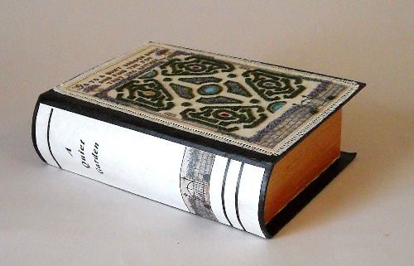

This PowerPoint program is an exploration into the many ways to showcase needlework to make beautiful covers for books. You will see Catherine’s collection of accordion folded booklets, linen covered journals, and designs archivally attached to paper maché book boxes. There will be plenty of time for questions.

Accompanying the lecture will be a handout with directions for making the accordion folded inserts, covering them, and making journal covers with your needlework.

A 1-hour Zoom® Power Point® program with 60+ slides.
If you have any questions or need additional information, please contact me. Catherine

Catherine Jordan
3435 Pleasants Road
Powhatan, VA 23139
jordancd@verizon.net

Needlework Covered Boxes
Catherine Jordan

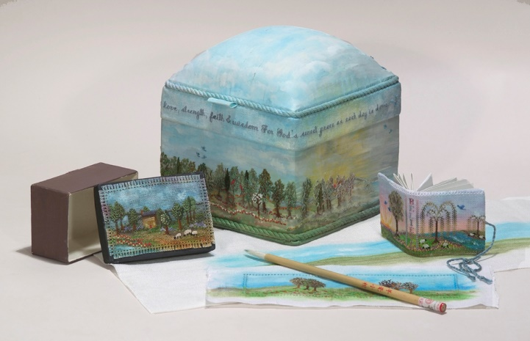

So many possibilities for the use of boxes to use for fabric and needlework finishing! From simple flat pieces mounted on wood or paper maché boxes to starting with a commercially made box and using it as a base for your needlework. From simple designs and finishes to boxes that challenge the most advanced needleworker, this program offers something for everyone. It is sure to spark some ideas for alternate finishing with boxes.

A 1-hour Zoom Power Point program with slides showing the many possibilities of using boxes to finish needlework projects. A forum for participants to ask questions as they think about creativity and expanding their finishing options. You will see Catherine’s collection of needlework finished on a variety of boxes which will give you ideas for designing and finishing your own work.

This lecture is accompanied by an emailed pdf handout listing sources for boxes with pictures and links to suppliers.

If you have any questions or need additional information, please contact me. Catherine

Catherine Jordan
3435 Pleasants Road
Powhatan, VA 23139
jordancd@verizon.net

Plan to Finish First!

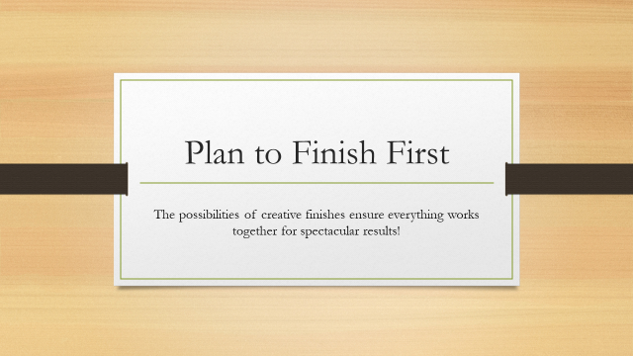

The finish of any piece of needlework becomes an integral part of the design affecting and hopefully contributing to the unity, message and purpose. As much care and thought should go into the planning of the finish as goes into the beginning design process. Learn how to combine the focus of designing a piece of needlework with the possibilities of creative finishes to ensure everything works together for spectacular results!

A 1-hour Zoom Power Point program with 50+ slides exploring design, fabric painting, alternate finishes and much more. A forum for participants to ask questions as they think about creativity and expanding their art and needlework horizons.

If you have any questions or need additional information, please contact me. Catherine

Catherine Jordan
3435 Pleasants Road
Powhatan, VA 23139
jordancd@verizon.net

