TRIBUTE
Designed by Debbie Rowley
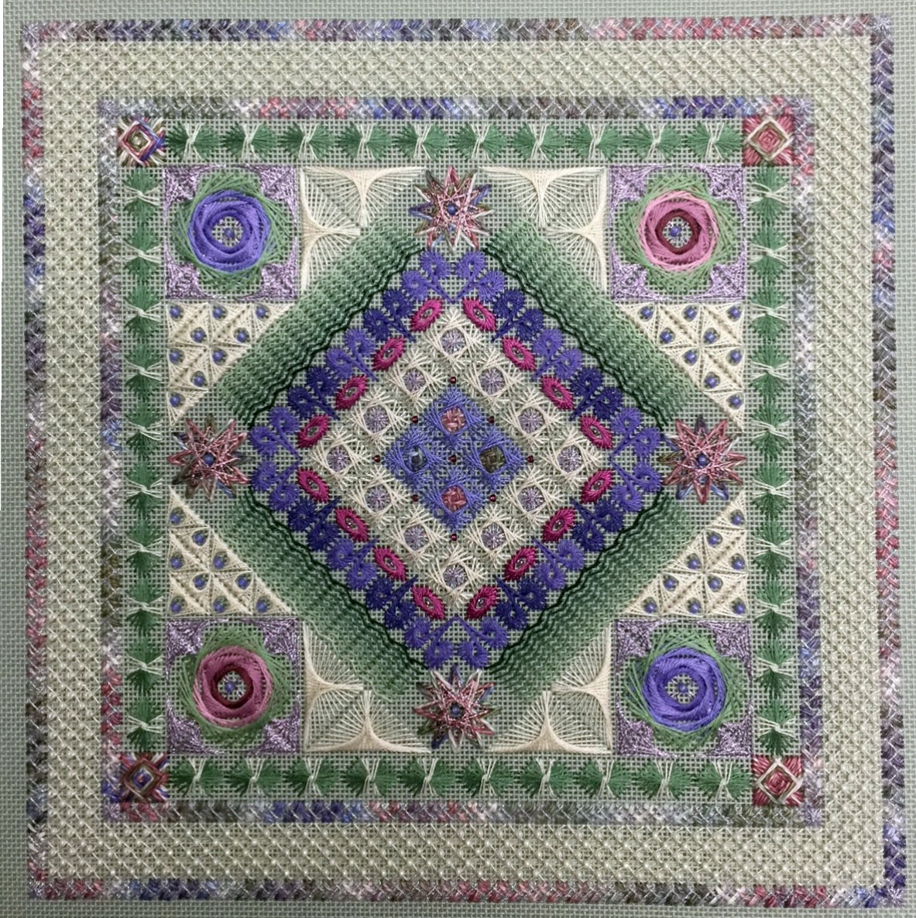

A tribute to the legendary Jean Hilton, this project features several “twisty” stitches attributed to the designer.
Teaching objectives:
- Encourage stitchers to develop an ease and confidence with “twisty” stitches
- Explore complex and layered stitches
- Discover several different thread textures

Tribute is filled with stitches developed by Jean Hilton. A center motif of small walnetos is stitched around Rhodes diamonds and waffle stitches, then moves into oblong Jessicas and crescents. Stacked herringbone stitches anchor 12 pointed stars, triangle Amadeus, layered Jessicas with arrow Amadeus, waffle stitches and a complex frame of Val’s stitch, double herringbone, and trellis stitch.
Stitches include walnetos, diamond Rhodes, upright waffles, Jessica, crescents, herringbone, double herringbone, trellis, Amadeus, 12 pointed star, Val’s stitch, layered partial Jessicas.
Duration | 2 day class
Kit Materials | 18 ct. sage green mono deluxe canvas, Caron Collection Watercolours, DMC cotton floss, DMC #8 pearl cottons, DMC Satin Floss, Kreinik #4 and #8 braids, Rainbow Gallery Silk Lame’ Braid and Neon Rays, Mill Hill glass seed beads, size 22 tapestry needles, beading needle
Size | 10″ x 10″ on 18 ct. canvas, 180 x 180 stitches
Students supplies | 2 pairs 16″ stretcher bars with tacks or staples, scissors, laying tool, magnification and lighting if needed

Date: Friday – Saturday 7 – 8 June 2024 8:30 – 4:30

Location: Camarillo, CA United Methodist Church, 291 Anacapa St., Camarillo, CA.

Cost: Kit fee will secure your spot in the class. Ghosts are allowed with an additional postage fee of $15 to mail the kit. Teacher fee is To Be Determined but should be less than $85.

Full Kit: $120 ___________ Attending:

Chart only $65 ___________
Chart + canvas $50 ___________ Ghost:
Postage $15 ___________

TOTAL SENT: ___________

- NAME: __________________________________________________________________
- ADDRESS: ________________________________________________________________
- CITY, STATE, ZIP _______________________________________________________________
- PHONE NUMBER, EMAIL ________________________________________________________________

Make check payable to Channel Islands Chapter EGA

Mail form and payment to: Mari Bangs, 1904 Baja Vista Way, Camarillo, CA. 93010

Questions: Call 805-231-0733 (voice and text), danslamari@gmail.com

Deadline to sign up is 26 April 2024.

