The Channel Islands Chapter of the Embroiderers’ Guild of America (CICEGA)
is pleased to offer the following workshop
Star Dance
Designed and taught by Margaret Bendig
April 21 & 22, 2023

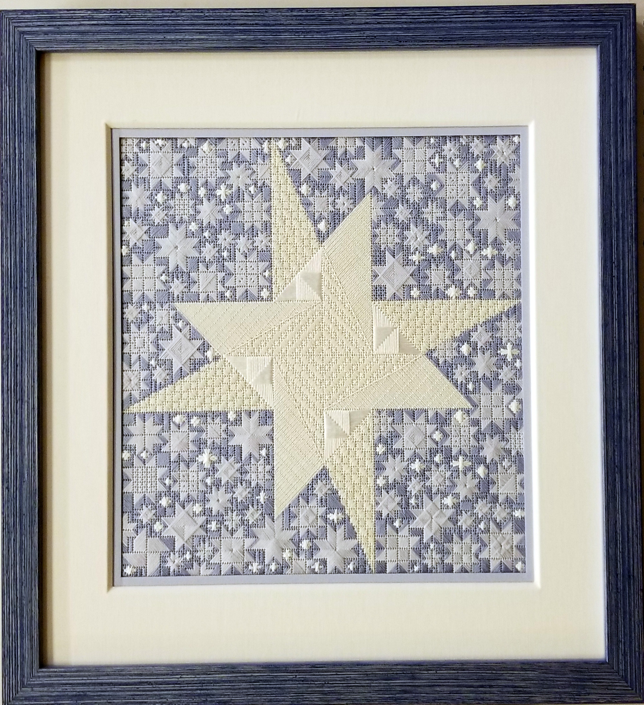

The finished design is 10″x 10″ on 18-count canvas
or 7.5″x7.5” on 24-count congress cloth.

Estimated kit cost for all attendees:
18-count with silk $155 or with cotton floss $100
24-count with silk $140 or with cotton floss $85

Registration for non-CICEGA members: $50
(Early registration, by February 22, 2023: $40)

9:00am to 4:00pm each day
St. Columba’s Church, 1251 Las Posas Road,
Camarillo, CA 93010
president@channelislandsega.org

Deposit and kit fee due by March 15, 2023

REGISTRATION – STAR DANCE, APRIL 21 & 22

Name___________________________________________________________________
Address _________________________________________________________________
Phone _________________________ EGA Membership Number _________________
E-Mail Address____________________________________________________________
Preferred Kit _____________________________________________________________

Make checks payable to Channel Islands Chapter and mail to
P.O. Box 1675, Camarillo, CA 93010
Questions? Contact President@channelislandsega.org

