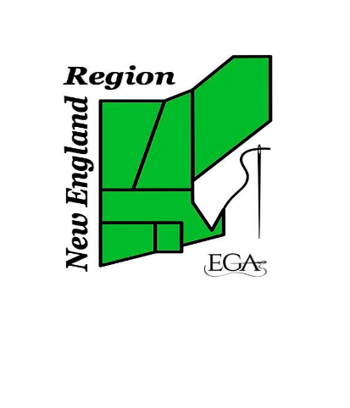
NEW ENGLAND REGION – EGA
Mini-Classes
Thursday, August 31, 2023
6:30 pm – 9:30 pm
Registration is open to all
Registration deadline: June 30, 2023
PLEASE PRINT ALL INFORMATION

Name: ______________________________________________________________________________________
Street address: _____________________________________________________________________________
City/State/Zip: ______________________________________________________________________________
Email address: ______________________________________________________________________________
Phone: _______________________________________________ EGA member number: _______________
Chapter: _____________________________________________ Region ______________________________
Registration must be accompanied by payment of the $50.00 registration fee for classes or $20.00 registration fee for lecture and kit fee for your first-choice class.
Registrations will be accepted and processed provided that payment is postmarked no later than DEADLINE
Form of payment: We can accept checks only
Refund policy: Registration fee and kit fee will be refunded in the case of a class cancellation or if the registrant withdraws from the mini-class.
Class Selection  We urge you to indicate first, second, third choices | Kit Cost | Choice # | Check if willing to be class angel
Tea Cozy Lecture by Suzanne Bruno | $0
Lovely Leaves Acorn Scissors Fob by Denise Harrington Pratt | $32
Filigree Ornament – Lobster and Moose by Catherine Jordan | $50
Intergalactic Fruit Salad by Amee Sweet_McNamara | $10
Serena’s Scissors Tip Protector by Serena Dube | $38
Mail completed form and payment (check made payable to NER-EGA to:
Beth Lindsay, mini-class registrar, 10 Merrymeeting Dr, Merrimack, NH 03054
Payment enclosed:
Registration mini-class $50.00
Registration lecture $20.00
Kit fee
Total

Questions to Susan Polumbo biggregp@aol.com or Beth Lindsay crewelBeth@gmail.com

