Stitching in the Rogue
2022 Greater Pacific Region Seminar
Request for Proposals and Proposal Submission Guidelines

The Greater Pacific Region of The Embroiderers' Guild of America is pleased to announce Seminar 2022, Stitching in the Rogue.
The Seminar will be held at Ashland Hills Hotel & Suites, Ashland Oregon. Ashland’s surroundings will inspire the artist in any needleworker. The city, which is known world-wide for the annual Oregon Shakespeare Festival, draws thousands of visitors to its theaters, galleries, and restaurants. Located in the Rogue Valley with its rolling hills and rushing rivers, Ashland is also nestled at the base of the breathtaking and historically important Siskiyou mountain range. This vibrant little city offers activities for those who love indoor as well as outdoor activities.
Please accept this letter as your invitation to submit proposals for up to five days of teaching for 1-day, 2-day, 3-day and 4-day classes. We wish to offer classes in a variety of techniques and proficiency levels, with 1-day class emphasis toward opportunities for students to explore new techniques and for beginning-level students to attend seminar.
Classes start on Saturday, July 9. Teachers should plan to arrive by 2 P.M. on Friday, July 8 to allow attendance at the Teacher Welcome at 3:30 and the Opening Banquet. Most teachers will likely depart on Thursday, July 14, so they may attend the closing banquet on Wednesday evening July 13.
Teachers should submit teaching proposals totaling a minimum of four days. These may include a combination of 1-day, 2-day and 3-day classes, or 4-day classes.
Compensation includes:
- Teaching Fee of $400 per day.
- Hotel accommodations (double occupancy) at Ashland Hills Hotel & Suites for period of contract.
- The lesser of Economy round-trip airfare or mileage, plus travel expenses.
- Meals during the period of the contract.
  - Daily breakfast as part of the hotel room package.
  - Region meeting lunch.
  - Opening and Closing banquets.
  - Meal per diem for meals not provided.
Teachers are responsible for the cost of shipping kits and/or class supplies and are encouraged to include any shipping expenses in their kit fees. Contracted class projects shall not be taught within GPR for 60 days before Seminar or for 60 days following Seminar.
Faculty selection will take place on/about April 1, 2021 and all applicants will be advised if they are selected no later than April 15, 2021. All proposals and accompanying materials are to be submitted by e-mail to Teresa Frank at seminar2022faculty@ega-gpr.org and received no later than March 1, 2021.
PROPOSAL REQUIREMENTS
All teaching proposal(s) must be the teacher's own work. Encore pieces, those that have been taught previously, will be considered; they must be clearly marked as “Encore” on the submission. Please specify if your proposal is part of a series or very similar to other pieces you have taught. If this is the case, please include photographs of the previous piece(s) and indicate when and where they were taught.
Proposals should include the following items for each specific piece. Please, do NOT send projects.
- ICNA Standard Proposal Summary Sheet.
- An accurate course description with an overview of the material covered and class goals.
- A detailed drawing, colored illustration and/or chart for work in progress, or
- More than two .jpg or.tiff photographs of completed piece.
- A legend of stitches, threads, and colors with a thread palette.
- Student proficiency level:
  - Basic: The stitcher has no experience in the technique being taught.
  - Intermediate: The stitcher has knowledge of the basic stitches, the materials, and their use in the given technique.
  - Advanced: The stitcher is proficient executing the simple and difficult stitches in the technique. The stitcher also has knowledge of color and design, which will allow for exploration and creativity.
- A list of kit contents and estimated cost.
- Design size.
- For a notebook course, include a detailed description with sample pages.
- Each proposal page should be clearly marked with both the teacher's name and the project name.
Supporting Materials should include:
- A Proposal Items Submission Sheet listing the contents of your submission package.
- A resume of not more than one page, which includes your embroidery education, teaching experience, and any specialized area of expertise.
We look forward to receiving your proposals!
Sincerely,
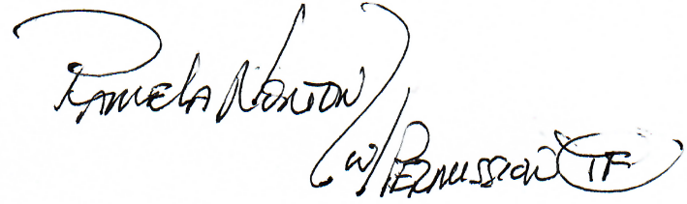
Pamela Norton
Seminar Chair, GPR Seminar 2022

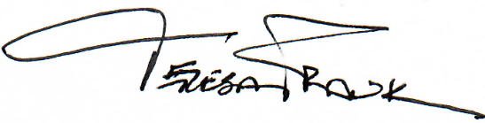
Teresa Frank
Faculty Chair, GPR Seminar 2022
131 Mount Baker Dr.
Sequim WA 98382
Telephone: 206 250 8381
E-mail: seminar2022faculty@ega-gpr.org

Enclosures: ICNA Universal Proposal Cover Sheet
Proposal Items Submission Sheet

